

# Table of Contents

Table of Contents 1

Lesson Plan 3

Background and Rationale 4

objective 1: 6

Dragon and Outlook Configuration 6

Configure Dragon for Use with E-mail 6

Increase Accuracy from E-Mail 10

objective 2: 13

Understand how to Start Outlook, Navigate Folders, Check for New E-mail, and Open and Close E-mails 13

Starting Outlook 13

Navigating Mail Folders 13

Opening E-mails 14

Closing E-mails 14

Objective 3: 15

Compose, Send, Reply to, and Forward E-mail 15

Composing E-mails 15

Sending E-mails 16

Replying to E-mails 16

Forwarding E-mails 17

objective 4: 18

Understand how to Print and Delete E-mail and Work with Attachments 18

Printing E-mail 18

Deleting E-mail 18

Working with Attachments 19

Objective 5: 20

Learn how to use the Out of Office Assistant 20

Enabling Your Out of Office Assistant 20

Disabling the Out of Office Assistant 21

exhibit a - general user tips 22

exhibit B- keyboard shortcuts 23

Exhibit C - phonetic alphabet 24

FEEDBACK SHEET 25

# Lesson Plan

#### Lesson Objectives

At the completion of this lesson, using speech commands, you will be able to:

1. Configure Dragon NaturallySpeaking ("Dragon") for use with Microsoft Outlook.
2. Start Outlook, navigate folders, check for new e-mail, and open and close e-mail.
3. Compose, send, reply to, and forward e-mail.
4. Print and delete e-mail and work with attachments.
5. Enable and disable the Out of Office Assistant.

#### Length of Lesson

2 hours

# Background and Rationale

Dragon NaturallySpeaking is "speech recognition" software that is available to assist employees who have a broad range of upper body mobility impairments that restrict their ability to use a mouse or keyboard. Dragon speech recognition reduces the pain and frustration of daily computer tasks by helping reduce the number of keystrokes and mouse clicks needed to manage computer applications – all by voice commands.

#### Utilizing Optional/Alternative Command Language

More often than not, there are multiple voice commands that are available to perform the same task with Dragon. Please review the table below for an explanation of how this user guide indicates optional or alternative language.

| **Symbol** | **Action** | **Description** |
| --- | --- | --- |
| **[ ]** | Indicate Optional statements | Brackets indicate Optional statements: [ ]. Optional statements are parts of the command you do not have to say for the command to work. For example, in the command "**[go to|switch to|view|display|show|open]** **Add to Favorites**," the only words that are required for the command to work are "**Add to Favorites**." "**Go to**," "**switch to**," "**view**," "**display**," "**show**," and "**open**" are optional. |
| **( )** | Indicate Alternative (i.e., Or) statements | Parentheses indicate alternative (i.e., Or) statements: ( ). Or statements designate a number of alternative commands and are usually preceded or followed by other commands. Or statements are shown by a separator bar, |, usually enclosed by parentheses. For example, the command "**(go to|switch to) folder**" indicates that the user may say, "**go to folder**" or "**switch to folder**." |
| **|** | Separate alternative language | The separator bar, |, is used to separate alternative language in both Or statements and Optional statements. |
| **< >** | Indicate lists | Lists are indicated by left and right angle brackets: < >. In this user guide, left and right angle brackets < > are used to indicate either a specific list used by the command, or may be used to indicate a variable. For example, in the command "**move down <1-20> lines**," **<1-20>** indicates that the user may select any number of lines from 1 to 20. |

Table 1: Symbols Indicating Optional or Alternative Command Language

#### Dragon User Tips

**User Tips** appear throughout this user guide. New Dragon NaturallySpeaking users may find it beneficial to review the **General User Tips** section, located in **Exhibit A**, prior to continuing with this guide.

# objective 1:

## Dragon and Outlook Configuration

### Configure Dragon for Use with E-mail

#### Overview

The **Options** dialog box allows you to configure Dragon to work best with your most frequently used applications. For example, the **Commands** tab of the **Options** dialog box lets you determine whether the word "**click**" is required to select menu items.

#### Correction Options

Access Dragon **Correction** options (See Figure 1):

* + Say, "**switch to DragonBar**."
  + Say, "**Tools**."
  + Say, "**Options**."
  + The **Correction** tab is generally the first page displayed in the **Options** dialog box. To switch to the **Correction** tab, if necessary, say, "**Correction**."

"**Spell**" **commands bring up Spell dialog box**. (User preference). If you check this checkbox, the **Spell** dialog box will appear when you speak a spelling command ("**spell <letters>**" or "**spell that <letters>**"). If you pause after saying, "**spell**," the **Spell** dialog box displays even if you do not check this option.

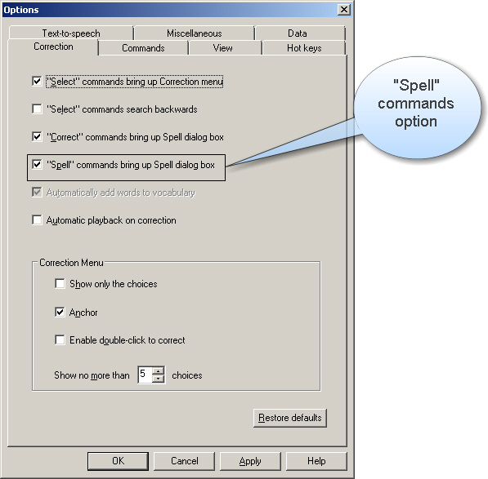

Figure 1: Options Dialog Box – Correction Tab

#### Commands Options

Access Dragon NaturallySpeaking **Commands Options** (See Figure 2):

* + Say, "**switch to DragonBar**."
  + Say, "**Tools**."
  + Say, "**Options**."
  + Say, "**Commands**."

**Enable HTML support** checkbox should be checked. Any change to this option does not take effect until you restart Dragon. If the checkbox is not checked, say, "**Enable HTML support**" to mark the checkbox.

**Enable commands in HTML windows** checkbox should be checked. You must have this option selected in order to use voice commands in certain Outlook dialog boxes when you are creating or editing messages in HTML format. If the checkbox is not checked, say, "**Enable commands** **in HTML windows**" to mark the checkbox.

**Require** "**Click**" **to select hyperlinks in HTML windows**. (User preference). If you select this checkbox, you are required to speak the word "**click**" to select a hyperlink. By default, this feature is off. If the checkbox is not checked, say, "**Require 'Click' to select hyperlinks in HTML windows**"to mark the checkbox.

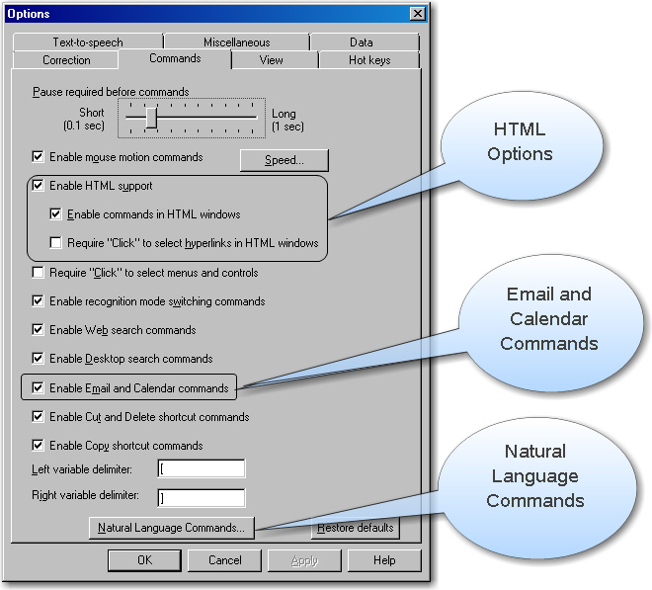

Figure : Options Dialog Box – Commands Tab

The **Enable Email and Calendar commands** checkbox should be checked. (See Figure 2.) This option lets you control Outlook's e-mail and calendar functions using commands patterned on your normal speech. This option is checked by default. To check or uncheck this checkbox, say, "**Enable Email and Calendar commands**."

**Natural Language Commands**: Say, "**Natural Language Commands**" or say, "**press alt n**" to activate the **Natural Language Commands** button. (See Figure 2 above.)

The **Enable Natural Language Commands** checkbox should be checked. (See Figure 3.) Say, "**Enable Natural Language Commands**" to mark the checkbox. This feature uses an additional eight megabytes of memory and requires that you restart your computer before it takes effect. If you disable Natural Language Commands, you can still perform all actions by voice although it will take a few extra steps. For example, if you have not enabled Natural Language Commands, the command"**to field**" will not move to the "To" field in an e-mail. You must say, "**press tab**" or "**press shift tab**" until you move to the appropriate field.

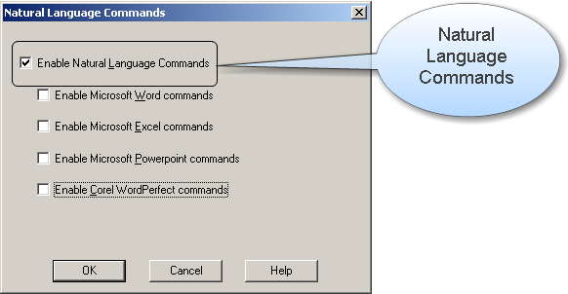

Figure : Natural Language Commands Dialog Box

#### Formatting Options

Access Dragon formatting options (See Figure 4):

* + Say, "**switch to DragonBar**."
  + Say, "**Tools**."
  + Say, "**Formatting**."

**Automatically format text** checkbox should be checked. The **Automatically format text** checkbox in the **Formatting** dialog box turns on different forms of automatic number and word formatting, allowing you to dictate Web addresses and e-mail addresses in a more natural way.

**Web and e-mail addresses** checkbox should be checked. The checkbox is not checked, say, "**Web and e-mail addresses**"to mark the checkbox. This option allows you to dictate e-mail addresses in a natural manner, linking names (e.g., "John.Doe@ssa.gov" instead of "John dot Doe at SSA dot gov") and recognizing the word "at" as the @ sign.

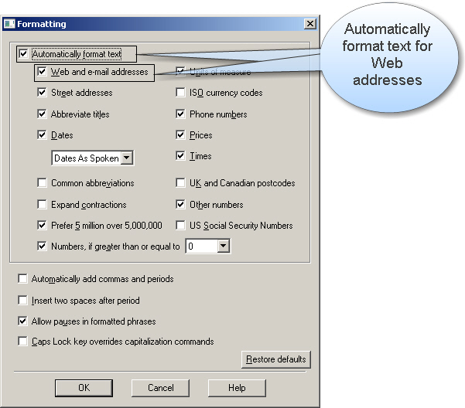

Figure 4: Formatting Dialog Box

### Increase Accuracy from E-Mail

Before using Outlook e-mail and calendar functions for the first time, you should run the **Increase accuracy from e-mail** tool (See Figure 5), so that Dragon can automatically add to your custom vocabulary and identify the names of your Contacts.

1. Say, "**switch to DragonBar**."
2. Say, "**Tools**" or "**press** **alt t**."
3. Say, "**Accuracy Center**"or "**press c**."
4. Say, "**Increase accuracy from email**."
5. Say, "**Next**" or "**press alt n**."
6. If Microsoft Outlook is not checked, say, "**move down one**" to highlight it.
7. Say, "**press spacebar**" to check the box.
8. Say, "**Consider all e-mail**"or"**press alt l**"to select the radio button.

**User Tip**:

Use the "**Consider all e-mail**" option for your first scan (See Figure 6). For subsequent scans, you can select the "**Consider email written since my last scan**" radio button (marked by default).

1. Say, "**Next**" or "**press alt n**."
2. Say, "**Allow access for**" or"**press alt a**."
3. Say, "**Tab**."
4. Say, "**10 Minutes**."
5. Say, "**Allow**."

**User Tip**:

Be patient. This process will take several minutes.

1. After scan completes, say, "**Next**" or "**press alt n**."
2. Say, "**Check All**" or "**press alt a**" to add all of your contacts to your vocabulary.
3. To select individual contacts, say, "**Contacts**" or "**press alt c**."
4. Say, "**move down <1-20>**" to highlight the desired contact.
5. When the name you wish to add highlights, say, "**press spacebar**" to add that person as a contact.
6. Say, "**Next**" or "**press alt n**" twice.
7. Say, "**Finish**" to save your contacts.

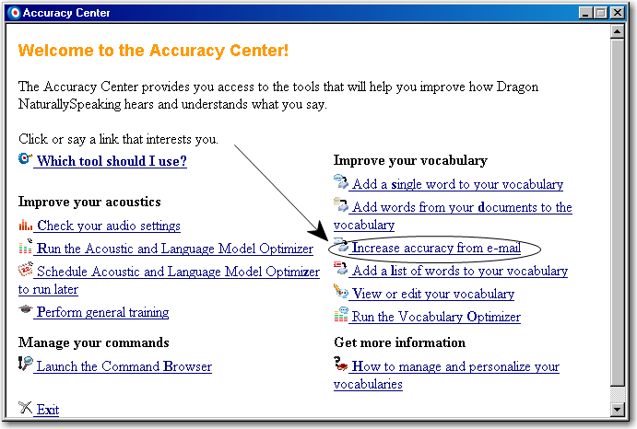

Figure 5: Accuracy Center Panel

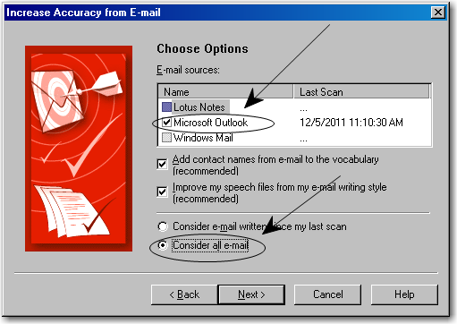

Figure 6: Increase Accuracy from E-mail Dialog Box

# objective 2:

## Understand how to Start Outlook, Navigate Folders, Check for New E-mail, and Open and Close E-mails

### Starting Outlook

1. Say, "**Start Mail**" to open Microsoft Outlook if the program is currently closed.
2. Outlook will open in your **Inbox**, even if you were in a different folder during your last Outlook session.
3. If you already have Outlook open but are in a different application, say, "**switch to Outlook**."

**User Tip**:

You can use the words "**mail**," "**e-mail**," and "**message**" interchangeably for commands in Outlook. You can also add the optional words "**the**," "**this**," and "**that**." For example, "**send message**," "**reply to this**," "**delete that**."

### Navigating Mail Folders

1. Say, "**Go**" or "**press alt g**," then say, "**Folder**."

Alternatively, you can say, "**(go to**|**switch to) folder**" or "**press control y**." Using these commands will open the **Go to Folder** dialog box. The **Go to Folder** dialog box displays your folder list and you can use it to navigate between folders and to create new folders.

1. Say the name of the folder to which you want to navigate. For example, to go to your **Drafts** folder, say, "**Drafts**" and then "**OK**."
2. To expand your **Inbox**, **Personal Folders**, or other folder (i.e., open the plus (**+**) sign next to it), say, "**move right**"or"**press right arrow**."

**User Tip**:

To navigate by voice directly to a folder, the folder must be visible on the screen. Otherwise, you must move down the list until the folder comes into view. Alternatively, you can move to the folder by saying, "**press**" followed by the first letter of the folder. For example, to move to your Personal Folders or Public Folders, say, "**press p**." You can repeat this process as many times as is necessary to highlight the desired folder.

### Opening E-mails

1. To check for new e-mail, say, "**check for new mail**," or "**press control m**."
2. To open an e-mail you must first select it (i.e., highlight it) in your list of messages. Simply say, "**open e-mail**."
3. To navigate down to another message in the list, say, "**move down <1-20> [lines]**" or say, "**[move] down <1-20> lines**." For example, to move down three messages, say, "**move down three lines**."
4. To navigate up to another message in the list, say, "**move up <1-20> [lines]**" or say, "**[move] up <1-20> lines**." For example, to move up three messages, say, "**move up three lines**."

### Closing E-mails

1. To close an e-mail, say, "**close e-mail**" or "**click Close**."

# Objective 3:

## Compose, Send, Reply to, and Forward E-mail

### Composing E-mails

1. Say, "**new e-mail**" or "**press control n**."
2. If the person you are e-mailing is listed in your **Contacts**, you can say, "**send e-mail to <Person's Name>**" to automatically have that person's e-mail address populate the **To** field.
3. If the person is not in your **Contacts**, dictate the e-mail address as you would normally say it. For example, to send an e-mail to john.smith@hotmail.com, say, "**John dot Smith at hotmail dot com**."
4. To enter e-mail addresses in all lowercase letters, use the "**No Caps On**" and "**No Caps Off**" commands.
5. **Spell Mode** may also be useful for dictating Web addresses. Say, "**Spell Mode On**" or "**switch to Spell Mode**," and then say any combination of letters, numbers, or symbols. You can return to normal dictation by saying, "**Spell Mode off**" or "**Normal Mode on**."
6. To search for a name in the address book, say, "**Address Book**" or "**press** **alt period**." In the **Search** field, say the last name of the person you want to e-mail. Once you have found the person and their name is highlighted, say, "**click To**" or "**press alt o**" to bring their name into the **To** field and then say, "**OK**." The same can be done for the **Cc** and **Bcc** fields by saying, "**click Cc**" or "**press alt c**" and "**click Bcc**" or "**press alt b**" and then saying, "**OK**."
7. The following commands will let you move around the different fields in your e-mail:

|  |  |
| --- | --- |
| **Say:** | **To Move Cursor To:** |
| "**to field**" | To Field |
| "**CC field**" | CC Field |
| "**BCC field**" | BCC Field |
| "**subject field**" | Subject Field |
| "**body field**" | Body Field |
| "**first field**" | To Field |
| "**previous field**" | To return to the last field you were in |
| "**last field**" | Body Field |

Table 2: E-mail Navigation Commands

**User Tip**:

Add the words "**go to**" or "**move to**" before the name of the field to increase the reliability of the command. For example, "**go to CC field**" or "**move to to field**."

### Sending E-mails

1. When you have finished composing your e-mail say, "**send e-mail**" or "**press alt s**" to send your message.
2. If you would like to save your message to send later, say, "**Save**" or "**press control s**."

### Replying to E-mails

1. To reply to an e-mail, say, "**reply to e-mail**" or "**press control r**."
2. To reply to everyone copied on an e-mail, say, "**reply to all**," or "**press control shift r**."
3. Dictate your reply message in the body of the e-mail and then follow the instructions under **Sending E-mails** to send your message.

### Forwarding E-mails

1. To forward an e-mail, say, "**forward e-mail**" or "**press control f**."
2. Dictate your reply message, if needed, in the body of the e-mail and then follow the instructions under **Sending E-mails** to forward your message.

# objective 4:

## Understand how to Print and Delete E-mail and Work with Attachments

### Printing E-mail

1. To print an e-mail from either the **Inbox** or the message, say, "**print e-mail**" or "**press control p**."

**User Tip**:

If a dialog box displays asking about the number of copies, say, "**OK**" and then "**Numeral <1-x>**" to indicate the number of copies to send to the printer.

1. To specify a page range to print, say, "**Page range**" and the pages you want to print. For example, to print pages 1 - 5, after you move to the Page range field, say, "**one hyphen five**."
2. If you want to preview the message before printing, say, "**Preview**" or "**press alt v**." To print from the **Preview Pane**, say, "**Print**" or "**press alt p**."
3. From the **Print** dialog box, say, "**OK**" or "**click OK**" to send the e-mail to your printer.
4. To cancel printing, say, "**Cancel**" or "**click Cancel**."

### Deleting E-mail

1. To delete an e-mail, say, "**delete e-mail**" or "**click Delete**."

### Working with Attachments

#### Opening Attachments

1. To open an attachment, say, "**Open Attachment**."
2. If there is more than one item attached to the e-mail, say, "**open attachment <number>**." For example, if your message has three attachments and you want to want to open the third attachment, say, "**open attachment three**."
3. To close an attachment, say, "**Close**," "**click Close**," or "**close window**."

#### Attaching Files

1. To attach a file to an e-mail, say, "**Attach File**."
2. Say the path or name of the directory where the file is located. For example, if the file you would like to attach is located under **Documents**, say, "**Documents**."
3. Say, "**press tab**" or "**press shift tab**" until you get to the file list. Say part of the **File name** of the file you would like to attach. For example, for a file named "**November Status Report**," say, "**November**." If the file is not selected, say, "**space**" or "**press spacebar**" to highlight the file.
4. Say, "**Insert**" or "**press alt s**" to attach the highlighted file to the e-mail.

# Objective 5:

## Learn how to use the Out of Office Assistant

### Enabling Your Out of Office Assistant

1. Say, "**Tools**" or "**press alt t**."
2. Say, "**Out of Office Assistant**" or "**press u**."
3. Say, "**Send Out of Office auto-replies**" or "**press alt s**" to select the radio button.
4. If you want to specify a time range for your out of office message, say, "**Only send during this time range**" or "**press alt o**."
5. Say, "**Start time**," or "**Tab**" or "**press alt m**" to go to the **Start time** date field.
6. Say the start date: for example, "**November 14, 2011**."
7. Say, "**Tab**" to go to the **Start time** time field.
8. Say the start time: for example, "**10:00 am**."
9. Say, "**End time**" or "**Tab**" to go to the **End time** date field.
10. Say the end date: for example, "**November 18, 2011**."
11. Say, "**Tab**" to go to the **End time** time field.
12. Say the end time: for example, "**5:00 pm**."
13. Say, "**Inside My Organization**" or "**Outside My Organization**" to navigate between the two tabs.
14. Say, "**press shift tab**" to go to the text of your out of office message.
15. Add or edit your out of office message and say, "**OK**" to activate the **Out of Office Assistant**.

### Disabling the Out of Office Assistant

1. Say, "**Tools**" or "**press alt t**."
2. Say, "**Out of Office Assistant**" or "**press u**."
3. Say, "**Do not send Out of Office auto-replies**" or "**press alt n**" to select the radio button.
4. Say, "**OK**" to disable the **Out Of Office Assistant**.

# exhibit a - general user tips

If Dragon has difficulty in recognizing a commonly used word or phrase and you have tried correcting the misrecognition at least twice, use the train word feature to teach Dragon how you pronounce it.

* Say, "**Train** **Word**."
* Type or dictate the desired word or phrase.
* Say, "**Go**."
* Say the word as you would normally say it. Try not to over-enunciate.
* Say, "**OK**."

In order to "train" the word, it must be part of your Vocabulary. If it is not part of your Vocabulary, you can add individual words to your Vocabulary by using the add word feature.

* Say, "**Add Word**."
* Type or spell the word, and say, "**OK**."
* "**I want to train the pronunciation of this word**" is the default. It is not necessary to train every new word you add because Dragon will predict the pronunciation. If Dragon does not recognize the words correctly, you should train them, and be sure you save your user files after adding new words.

Say, "**press alt**" to close a drop down menu or move from the **Menu Bar**.

In addition to Dragon voice commands, you can speak the access keys (the underlined letter in many menus and dialog boxes) to perform many tasks. For example, say, "**Tools**" or say, "**press alt t**" to access the **Tools** menu in the **DragonBar**.

# exhibit B- keyboard shortcuts

|  |  |
| --- | --- |
| **To:** | **Say,** "**press…**" |
| Create a new e-mail | **Ctrl N** |
| Open address book from an e-mail message | **Alt** |
| Add a selected person from address book to **To** field | **Alt O** |
| Add a selected person from address book to **Cc** field | **Alt C** |
| Add a selected person from address book to **Bcc** field | **Alt B** |
| Send an e-mail | **Alt S** |
| Check for new e-mail | **F9 or Ctrl M** |
| Open a selected e-mail | **Ctrl O** |
| Forward an e-mail | **Ctrl F** |
| Print an e-mail | **Ctrl P** |
| Delete an e-mail | **Ctrl D** |
| Save an e-mail | **Ctrl S** |
| Run spell check | **F7** |
| Close a dropdown menu | **Alt or Esc** |

Table 3: Keyboard Shortcuts

# Exhibit C - phonetic alphabet

| **To Type:** | **Say,** "**press…**" |
| --- | --- |
| a | "**alpha**" |
| b | "**bravo**" |
| c | "**Charlie**" |
| d | "**delta**" |
| e | "**echo**" |
| f | "**foxtrot**" |
| g | "**golf**" |
| h | "**hotel**" |
| i | "**India**" |
| j | "**Juliet**" |
| k | "**kilo**" |
| l | "**lima**" |
| m | "**Mike**" |
| n | "**November**" |
| o | "**Oscar**" |
| p | "**papa**" |
| q | "**Quebec**" |
| r | "**Romeo**" |
| s | "**sierra**" |
| t | "**tango**" |
| u | "**uniform**" |
| v | "**Victor**" |
| w | "**whiskey**" |
| x | "**x-ray**" |
| y | "**Yankee**" |
| z | "**Zulu**" |

Table 4: Phonetic Alphabet

# FEEDBACK SHEET

Request to the instructor:

As you use this training package, please document errors, omissions, and revisions and notify us of any required editing. At the completion of this segment, you should mail this form to the address on the next page.

**Source of report**:

Location of training: _______________________________

Your name: _____________________________________

Your phone number: ______________________________

**Timeframes**:

How much time did it take to present this material?

**Topics**:

Is there any material in the lesson that is covered but not relevant to your position that we should remove? If so, what?

Can you identify any topic not covered in this lesson that should be included?

**Complexity level**:

Are there any lessons that appear either too simple or too complex? Which ones? Why?

**Testing**:

How would you rate the usefulness of the tests and exercises?

1 2 3 4 5

Irrelevant Adequate Quite helpful

Please note your corrections below or attach a photocopy of corrected pages.

Page # Correction Needed

**Comments**:

Use the space below for your comments on how we can improve this material.

**Mail to**:

Gregory Gill

Social Security Administration

EHR Ste 100

6401 Security Blvd.

Baltimore, MD 21235

Or e-mail comments to [gregory.gill@ssa.gov](mailto:gregory.gill@ssa.gov?subject=Training%20Material%20Feedback)